 Name: Tahir Fareed
Roll No: SU92-BSAIM-F24-036
Program: BSAI (3-A)
Lab Task: 09

Data Exploration Documentation

Objective
This document provides an easy and professional explanation of the steps performed in Lab 9. The goal is to explore a dataset of used cars and understand its structure, features, and data quality.

1. Importing Libraries
The first step is importing the pandas library which is commonly used for data analysis tasks:
import pandas as pd
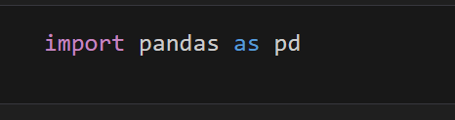

2. Loading the Dataset
The dataset 'used_cars.csv' was loaded using the read_csv() function:
df = pd.read_csv("used_cars.csv")
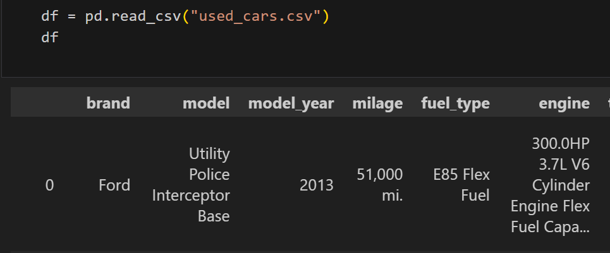

3. Displaying First Rows
The head() function was used to display the first few records of the dataset. This helps in understanding the format and values inside the dataset.

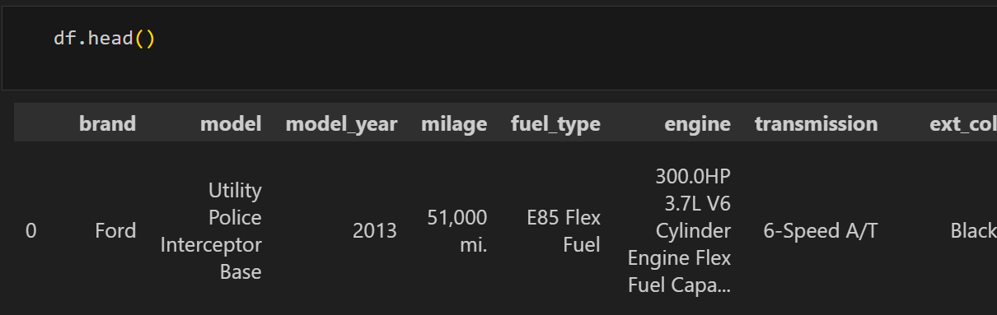

4. Dataset Information
The info() function was used to view summary information such as column names, data types, and number of non-null values in each column.

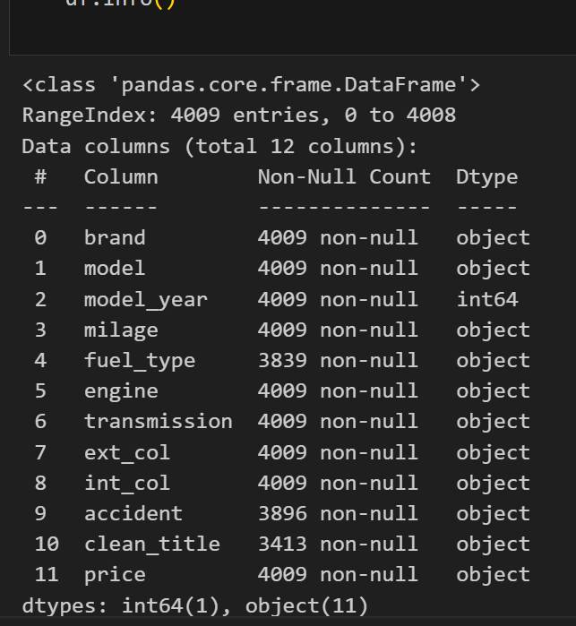

5. Dataset Dimensions
The shape attribute was used to find the number of rows and columns in the dataset.

6. Unique Values
The unique() function was applied to the 'price' column to see all unique price values in the dataset.
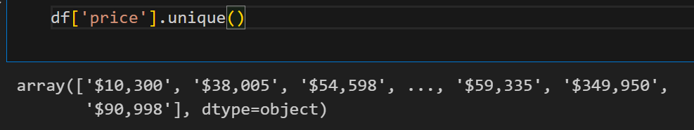

7. Counting Unique Values
The nunique() function was used to count the number of unique values in each column.

8. Checking Missing Values
The isnull() and isnull().sum() functions were used to detect missing values in the dataset. This helps determine if data cleaning is required.
